**INTERACTIVE CHALLENGE #1**

**INTERACTIVE CHALLENGE #2**

**INTERACTIVE CHALLENGE #3**

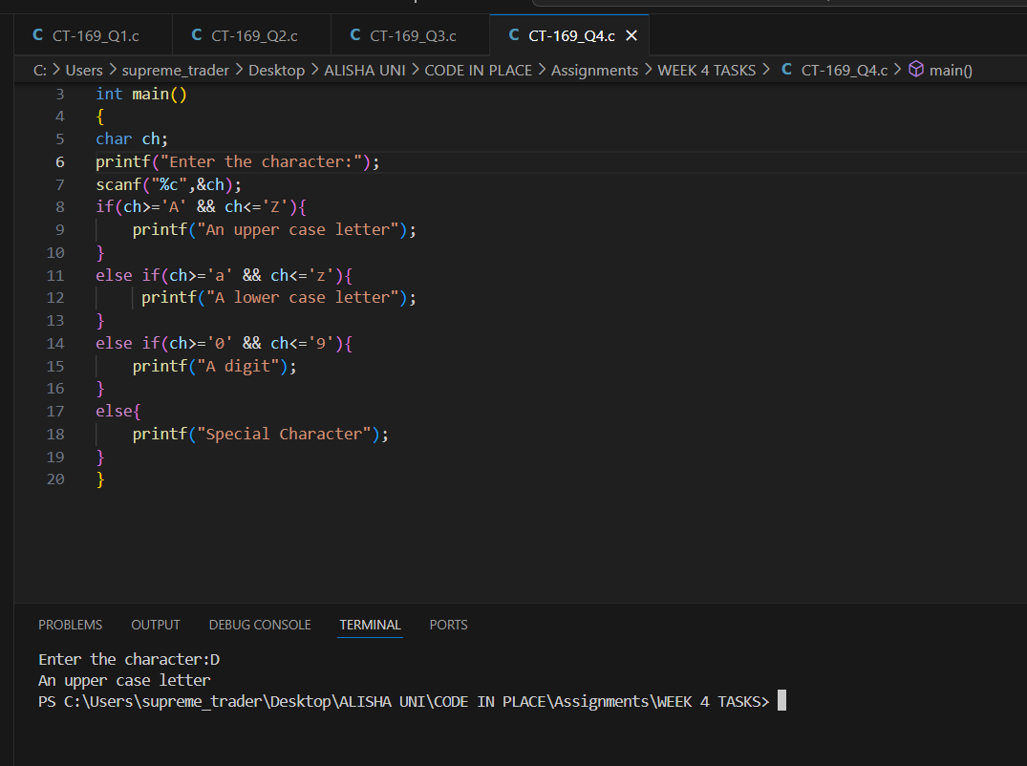**INTERACTIVE CHALLENGE #4**

